**Farm2Market Solution App Development Documentation**

**Project Lead:** TATA KEMAYO YANNICK  
**Date:** May 2025  
**Purpose:** Develop an app that connects farmers in Cameroon directly with buyers, solving market access issues, eliminating middlemen, and reducing food waste.

**📌 Backend Development Plan**

**🚀 Phase 1: Core Infrastructure & Marketplace Foundation**

These are the **must-have** backend functionalities to make the app operational.

✅ **User Accounts & Authentication**

* Secure **sign-up and login** for farmers, buyers, and admins.
* Multi-level access (farmer, buyer, admin).
* Token-based authentication for security.

✅ **Farmer Product Listings**

* API for **uploading products** (images, name, quantity, price, pickup location).
* Tags like "organic" or "fresh today".
* CRUD operations (Create, Read, Update, Delete).

✅ **Marketplace Search & Filtering**

* Buyers **search for products** via category, freshness, price, or location.
* Farmers listed in **interactive map view** (Geo-location API).

✅ **Chat & Direct Communication**

* Real-time **buyer-farmer messaging system** (WebSocket-based chat API).
* **Click-to-call feature** for direct negotiations.

✅ **Reservation & Sales Confirmation**

* Buyers **reserve products**, and farmers approve or reject requests.
* Notification system for **order status updates**.

✅ **Performance Tracker (Basic Analytics)**

* Farmers track **sales, reservations, and buyer interactions** weekly.
* Logging system for transaction tracking.

✅ **Admin Dashboard**

* Admins **verify farmer profiles**, manage transactions, and moderate listings.

**🌟 Phase 2: Trust & Identity Features**

Ensures safety, verification, and marketplace credibility.

✅ **Farmer Profile & Verification System**

* Unique **farmer ID, photo, village, trust rating**.
* ID verification via **national ID upload or village chief approval**.

✅ **Ratings & Reviews System**

* Buyers leave **feedback** on farmers' product quality and service.
* Database stores **average rating per farmer**.

✅ **Mobile Money (MoMo) Receipt Upload & Transaction Log**

* Farmers upload **payment receipts** for transaction tracking.
* Allows buyers to confirm payments securely.

✅ **Push Notifications & Alerts**

* Real-time alerts for **new messages, reservations, price updates**.
* Farmers notified of **weather and pest alerts**.

✅ **Weather & Pest Alerts**

* Farmers receive **forecast and disease warnings** related to crops.

**🎨 Frontend Development Plan**

**🚀 Phase 1: Essential Frontend Features**

These are the **core UI elements** required for user engagement.

✅ **Landing Page & Intro Screen**

* Welcome message with an overview of the app's purpose.

✅ **Language Selection Screen**

* Supports **English & French now** (later, Pidgin & voice support).

✅ **Login & Signup Screens**

* Different **sign-up flows for farmers, buyers, and admins**.

✅ **Buyer Dashboard & Marketplace View**

* Shows available farm produce with **images, price, stock status, location**.
* Search functionality integrated.

✅ **Search & Filtering System**

* Buyers search for products via **name, category, price, freshness, or location**.
* Farmers listed in **map view** (location-based filtering).

✅ **Farmer Dashboard & Product Management Screen**

* Farmers can **upload products, update stock, set pricing**.

✅ **Reservation & Confirmation UI**

* Buyers **reserve produce**, and farmers approve requests.
* Clear notifications for **order status updates**.

✅ **Chat & Call Features**

* Buyer-farmer **chat & call system** integrated into listings.

✅ **Ratings & Reviews System**

* Buyers rate farmers based on **product quality and service**.
* Display farmer reviews in profiles.

**🌟 Phase 2: User Experience Improvements**

Enhances usability and **builds trust** within the marketplace.

✅ **Farmer Profile & Verification UI**

* Farmers complete **profile setup** (photo, location, trust badge).

✅ **Push Notifications & Alerts UI**

* Real-time alerts for **messages, price updates, reservations**.

✅ **MoMo Payment & Receipt Management UI**

* Farmers upload **MoMo receipts** to confirm transactions.

✅ **Favorites & Bookmarking UI**

* Buyers save **favorite farmers and products** for quick access.

✅ **Offline Mode UI**

* Farmers can **create/edit listings even without internet**.

✅ **Admin Dashboard UI**

* Moderation tools for **approving/rejecting farmer profiles**.

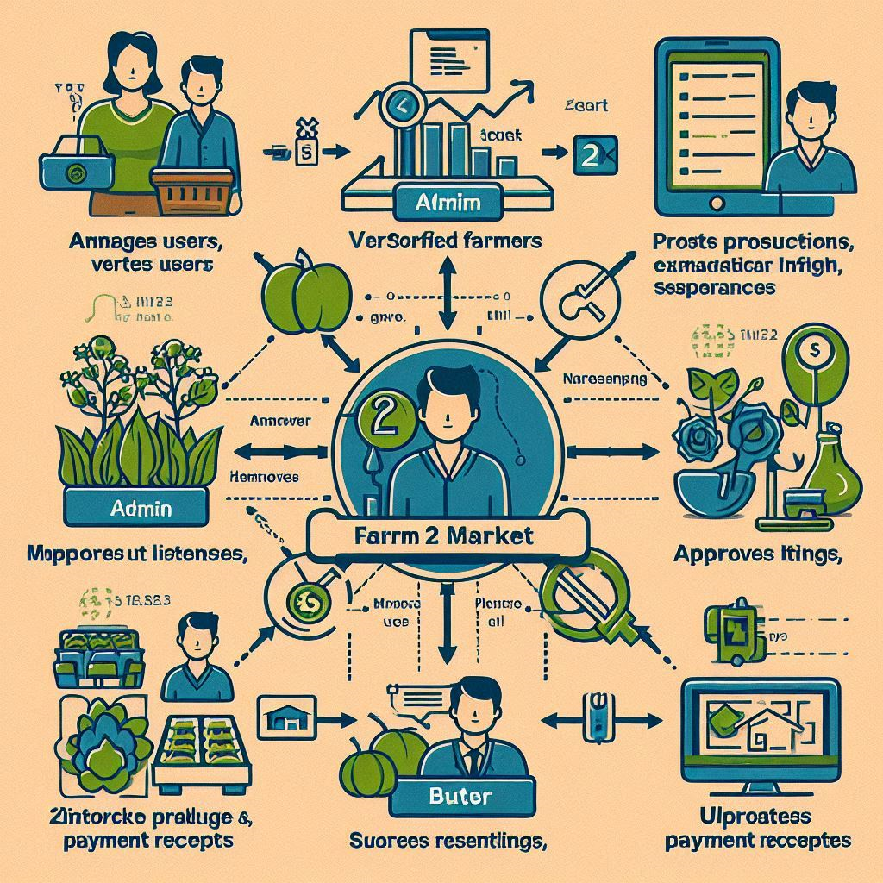

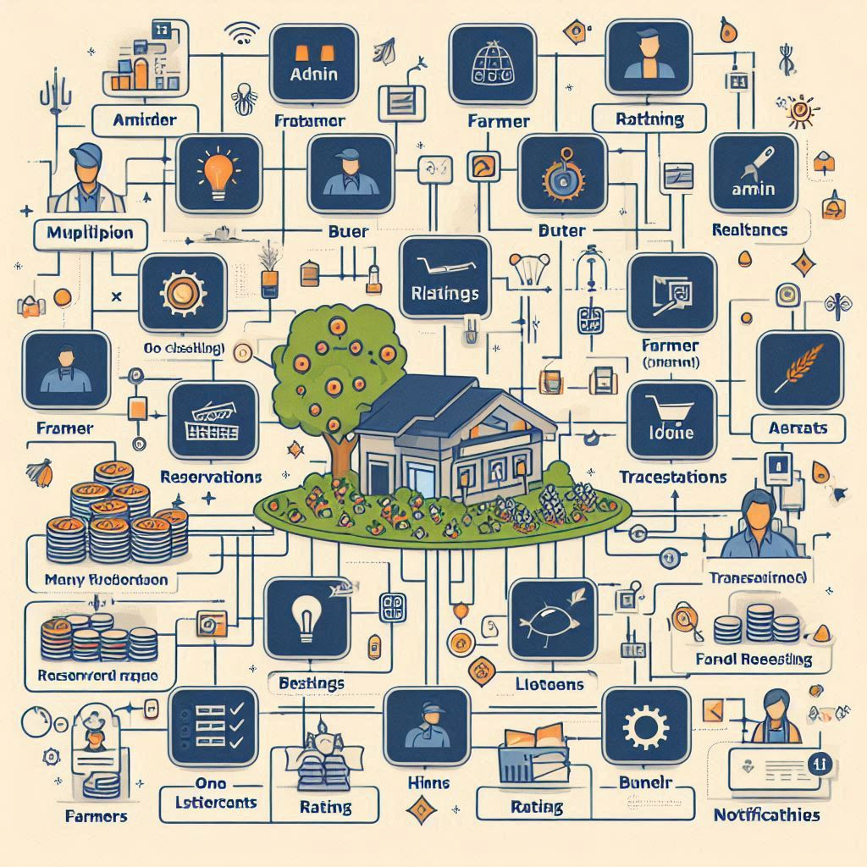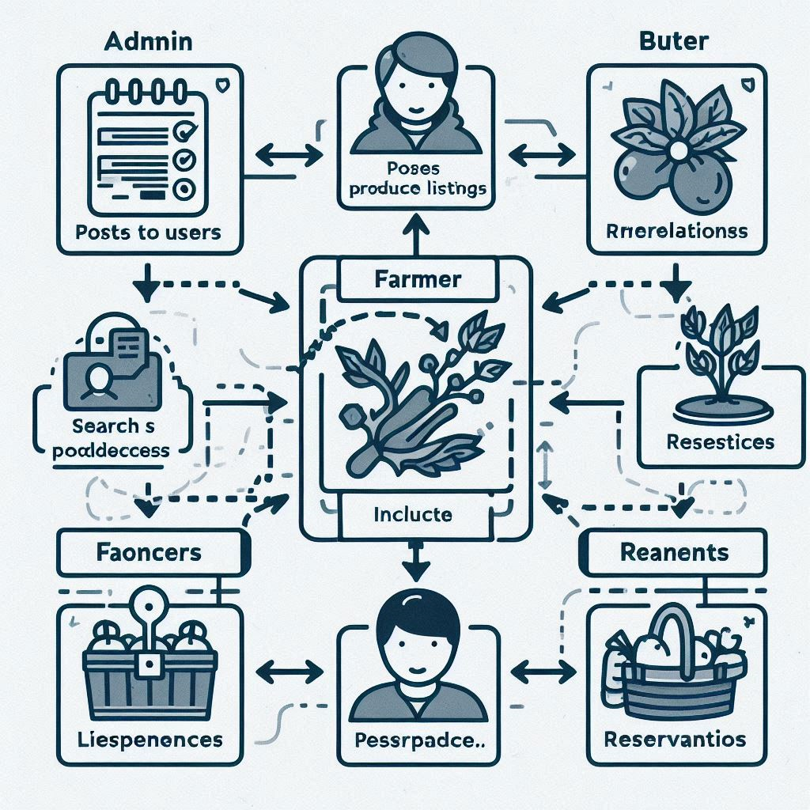

yenguemessahkate.yvana@ictuniversity.edu.cm